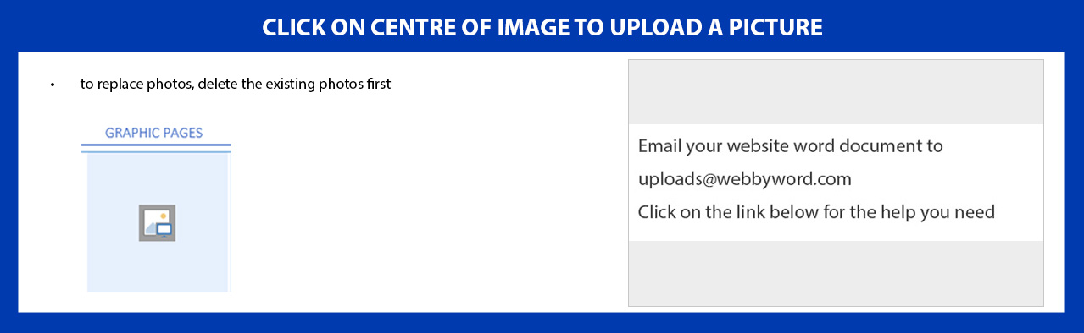

CONTROL CLICK FOR HELP

BaNner
HOME PAGE
Banner Name | [siteName]Creative Cuts[/siteName]
Logo Image | [logo][/logo]

Text for the Slider or Video
[slider]
[slider1]
Show Video?  (instead of Slideshow) | [IsVideo]No[/IsVideo]
Video URL | [homePageVideo] [/homePageVideo]
Video/Slider Heading | [heading] [/heading]
Video/Slider Sub-Heading | [subHeading] [/subHeading]

Enter a cross in the brackets here [sliderSameHeading] [Yes] [/sliderSameHeading] to assign the same heading & subheading on all slidesOr, enter unique text on each slide

Manual SliderEnter a cross in the brackets here [AutoSlider][Yes] [/AutoSlider]to make the slideshow manual & static

Name of Button on Slider | [ButtonName]H-A-I-R [/ButtonName]
Button Web Address Link | [anchorTag] http://theconfessionsofahairstylist.com/ [/anchorTag]
Remove Button | [removeButton]No[/removeButton]

Images for the Slider
Image 1 | [sliderImage]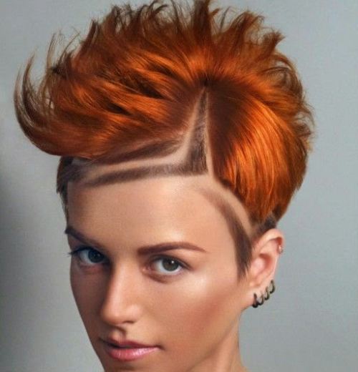[/sliderImage]  [/slider1] | Image 4 | [slider4]  [sliderImage]  [/sliderImage]  [/slider4]
Image 2 | [slider2]  [sliderImage]  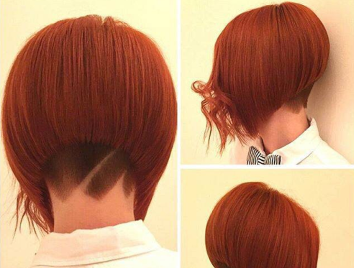[/sliderImage]  [/slider2] | Image 5 | [slider5]  [sliderImage]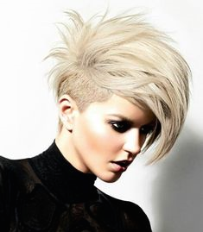[/sliderImage]  [/slider5]
Image 3 | [slider3]  [sliderImage]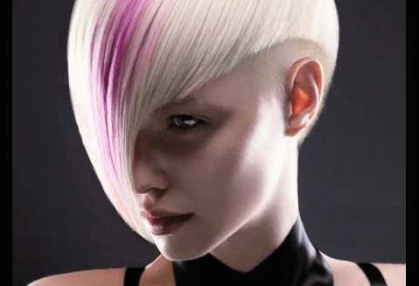[/sliderImage]  [/slider3]
[/slider]

CENter Page
HOME PAGE
Page Heading | [contentHeading]Has it been too long since your last haircut?[/contentHeading]
Page Text | [contentParaHeading] We excel in classic & creative affordable hairstyles for everyone, hair extensions, children cuts, hair braiding and hair straightening [/contentParaHeading]
Centre Image | [contentMidPic]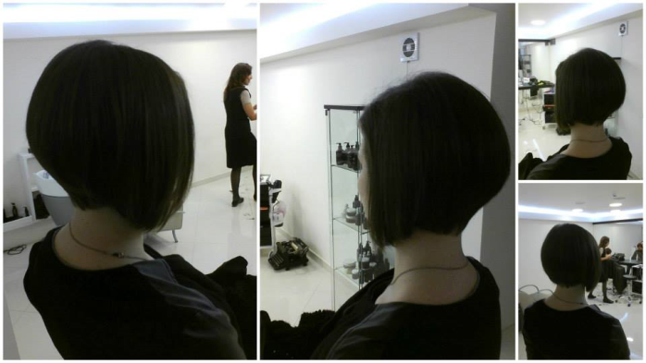[/contentMidPic]
Video Middle URL | [homePageMidVideo] [/homePageMidVideo]
Show Video (instead of image) | [IsMidVideo]No[/IsMidVideo]

HOME PAGE

C CONTACT Page ontact Information
[contactPage]
Could you tell us why you are contacting us?
[ContactReason]
[name] Could you tell us why you are contacting? [/name]
[option] New Inquiry [delete] No [/delete][/option]
[option] Existing Inquiry [delete] YES [/delete][/option]
[option] Site Feedback [delete] YES [/delete] [/option]
[option] Other [delete] YES [/delete][/option]
[option] [delete] Yes [/delete][/option]
[option] [delete] Yes [/delete][/option]
[/ContactReason]

[contactName] Name (required) [/contactName]
[contactNameplaceHolder] What's your name? [/contactNameplaceHolder]

[ContactEmail] Email address (required) [/ContactEmail]
[ContactEmailplaceHolder] What's your email address?[/ContactEmailplaceHolder]

[ContactPhone] Telephone number [/ContactPhone]
[ContactPhoneplaceHolder] What's your phone number? [/ContactPhoneplaceHolder]

[ContactMessage] Message [/ContactMessage]

Display Contact form on Frontpage?  (entering ‘No’ creates a unique Contact page) | [contactNeeded]Yes[/contactNeeded]
Telephone No. | [ContactClientPhone]0800 Private[/ContactClientPhone]
Announcement Above Map | [googleMapHeader]You’ll find me here[/googleMapHeader]
Google Map Address  (include nation) | [googleMapAddress] Wanganui, Manawatu, New Zealand ] [/googleMapAddress]
Text Below Map | [googleMapFooter]Wanganui, Manawatu, New Zealand[/googleMapFooter]

Contact Address
Heading | [contactAddressHeading] Address [/contactAddressHeading]

Line 1 | [contactAddress1]123[/contactAddress1]
Line 2 | [contactAddress2]River Avenue[/contactAddress2]
Line 3 | [contactAddress3]Wanganui 4500[/contactAddress3]
Line 4 | [contactAddress4]New Zealand[/contactAddress4]
Line 5 | [contactAddress5] [/contactAddress5]

Opening Hours
CONTACT PAGE
Opening Hours Heading | [openingHours]Opening Hours[/openingHours]
Line 1 | [contactOpenHours1] Sun – Mon Closed [/contactOpenHours1]
Line 2 | [contactOpenHours2]Tues – Fri 10.00 – 18.00[/contactOpenHours2]
Line 3 | [contactOpenHours3]Sat 10.00-16.00[/contactOpenHours3]
Line 4 | [contactOpenHours4] [/contactOpenHours4]
Line 5 | [contactOpenHours5] [/contactOpenHours5]
[/contactPage]

About Page
ABOUT PAGE
Please name the page  [for button on website’s banner]  Display the Page ? | [About]ABOUT[delete]  Yes[/delete] [/About]

Page Heading [aboutUsPageHeading]ABOUT CREATIVE CUTS[/aboutUsPageHeading]\\

[aboutUs]
SubHeading | [aboutUs1] [aboutUsHeading]A hairdresser is an artist whose work is always on display[/aboutUsHeading]
MainText | [aboutUsMainText]CREATIVE CUTS offers various services like haircuts, colour, hair-ups and hair extentions. Other services include shampooing, conditioning and blow drying. It is our goal to exceed your expectations. Come experience a family atmosphere where you come as guests and leave as friends. Our staff is highly trained with diversity in all aspects of Hair. We keep up on the latest trends in our industry by continually attending hair shows and education classes throughout the year. Come let us pamper you and provide you with quality services.[/aboutUsMainText]
Quote | [aboutUsQuote]Be realistic: plan for a miracle[/aboutUsQuote]
Author | [aboutUsAuthor]OSHO[/aboutUsAuthor]
Photo | [aboutImage][/aboutImage] [/aboutUs1]

About Page - Section 2
SubHeading | [aboutUs2]  [aboutUsHeading] [/aboutUsHeading]
MainText | [aboutUsMainText] [/aboutUsMainText]
Quote | [aboutUsQuote] [/aboutUsQuote]
Author | [aboutUsAuthor] [/aboutUsAuthor]
Photo | [aboutImage][/aboutImage]  [/aboutUs2]

About Page - Section 3
SubHeading | [aboutUs3][aboutUsHeading] [/aboutUsHeading]
MainText | [aboutUsMainText] [/aboutUsMainText]
Quote | [aboutUsQuote] [/aboutUsQuote]
Author | [aboutUsAuthor] [/aboutUsAuthor]
Photo | [aboutImage][/aboutImage]  [/aboutUs3]

About Page - Section 4
ABOUT PAGE
SubHeading | [aboutUs4] [aboutUsHeading] [/aboutUsHeading]
MainText | [aboutUsMainText] [/aboutUsMainText]
Quote | [aboutUsQuote] [/aboutUsQuote]
Author | [aboutUsAuthor] [/aboutUsAuthor]
Photo | [aboutImage][/aboutImage]  [/aboutUs4]
[/aboutUs]

PICTURE Pages
GRAPHIC PAGES
(Landscape format is preferable for most screens)
Graphic 1 Image | [graphicPageImage0]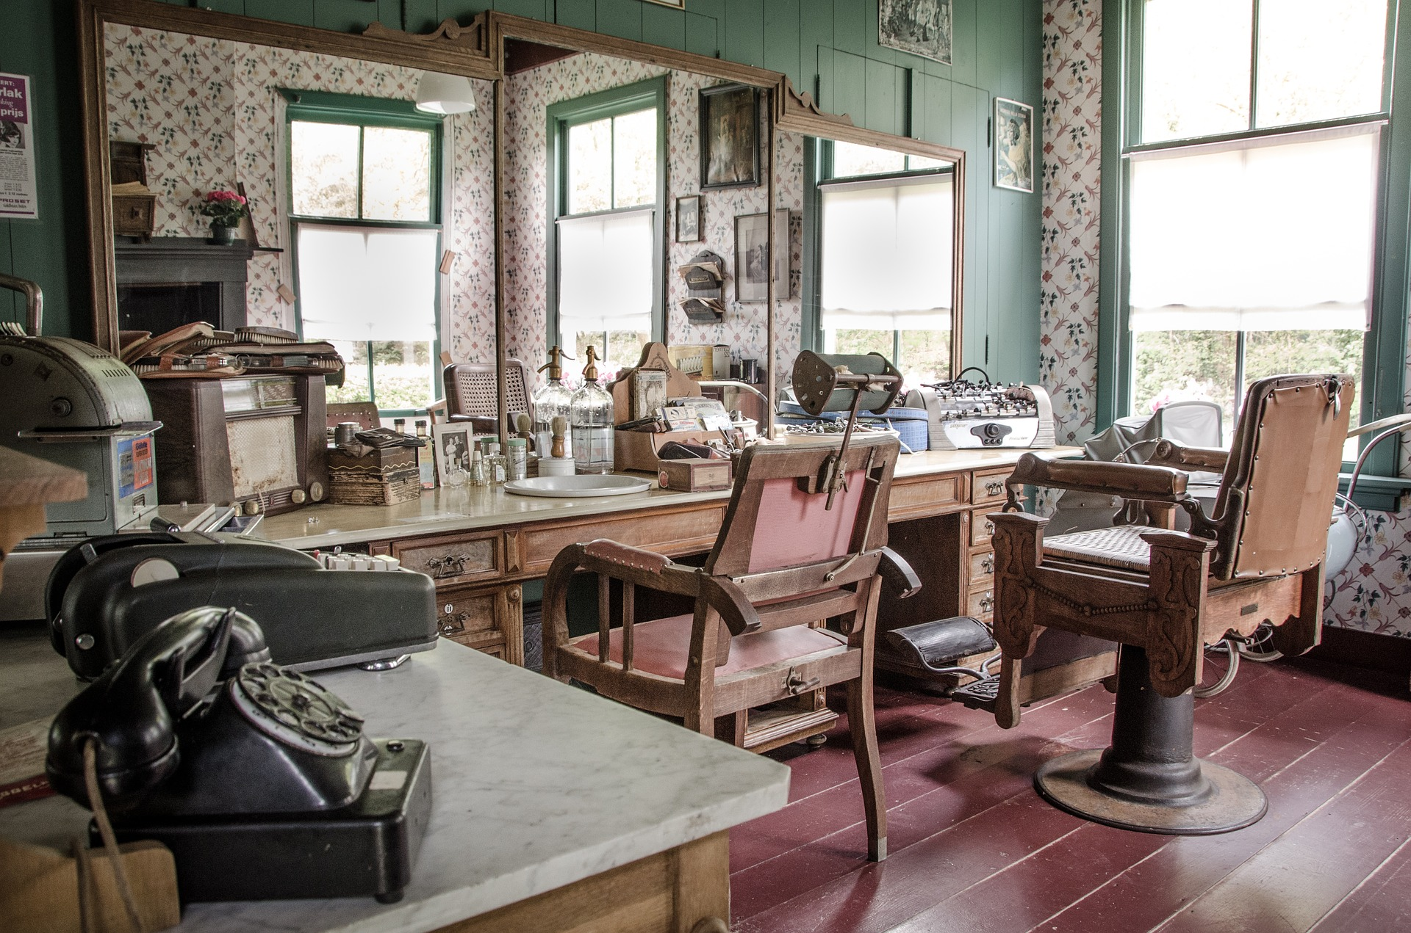[/graphicPageImage0]
Graphic 1 Page Name  Display The Page?  Remove Website Banner  Use Graphic1 for HomePage  Rename the old HomePage | [graphicsPage0]Creative Salon[delete]  Yes[/delete] [/graphicsPage0]  [graphicsPageBanner]No[/graphicsPageBanner]  [graphicsPageIsDefault]No[/graphicsPageIsDefault]  [homePage] [/homePage]
Graphic 2 Image | [graphicPageImage1]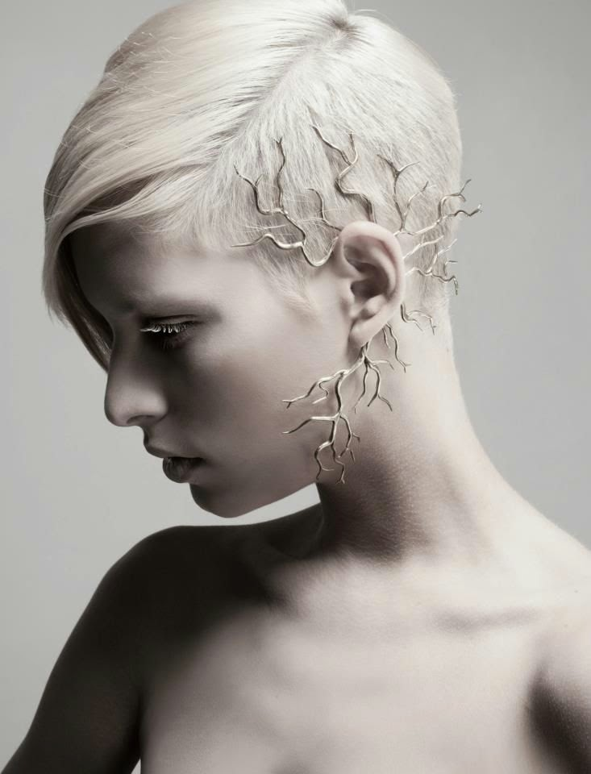[/graphicPageImage1]
Graphic 2 Page Name  Display The Page? | [graphicsPage1]Classic Comb Over[delete]  Yes[/delete] [/graphicsPage1]
Graphic 3 Image | [graphicPageImage2][/graphicPageImage2]
Graphic 3 Page Name  Display The Page? | [graphicsPage2] [delete]  No[/delete] [/graphicsPage2]

GRAPHIC PAGES

FONTS & Colours
CONTROL CLICK TO VIEW THE ONLINE COLOUR & FONT SELECTOR

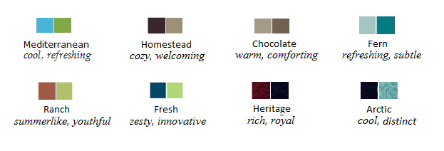
Theme Colour | [themeColour]Fresh[/themeColour]
\

CONTROL CLICK TO VIEW THE ONLINE COLOUR & FONT SELECTOR

Site Fonts
COLOURS & FONTS
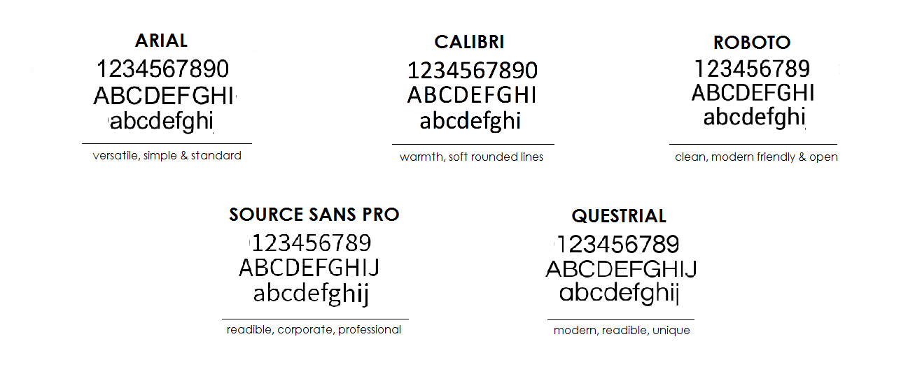
Select Font | [themeFont]Questrial[/themeFont]

SEO & WEB ADDRESSES
(Not visible to your site user, is for search engine use only, e.g. Google)
Keywords | [SiteKeywords]hairstyle, hairdressing, blond, shaving, hair extensions, children cuts, Hair salon, Hairdresser, Hair braiding, Hair straightening, Womens haircut, men, women, haircut[/SiteKeywords]
Description | [SiteDescription]Classic & Creative affordable, Hairstyles for everyone, hair extensions, children cuts, Hair braiding, Hair straightening[/SiteDescription]

SOCIAL NETWORK WEB ADDRESSES
PROVIDE BOTH:  - Blog Name  - Blog web address | [blogName] [/blogName]  [blogLink] [/blogLink]
Facebook | [facebook] https://www.facebook.com/jurate.savukynaite.56[/facebook]
LinkedIn | [linkedIn] ] [/linkedIn]
Twitter | [twitter] [/twitter]
Google+ | [googlePlus] [/googlePlus]
YouTube | [youtube] [/youtube]

MORE Banner Pages & Links
SETTINGS & LINKS
Page Link 1 (Name) | [additonalName1]Find Me on FB [/additonalName1]
Web Address | [additonalLink1]https://www.facebook.com/jurate.savukynaite.56[/additonalLink1]
Page Link 2 (Name) | [additonalName2] [/additonalName2]
Web Address | [additonalLink2] [/additonalLink2]
Page Link 3 (Name) | [additonalName3] [/additonalName3]
Web Address | [additonalLink3] [/additonalLink3]

Extra Footer Links
Footer Link 1 (Name) | [additionalFooterName1]Find Me on FB [/additionalFooterName1]
Web Address | [additionalFooterLink1]https://www.facebook.com/jurate.savukynaite.56[/additionalFooterLink1]
Footer Link 2 (Name) | [additionalFooterName2] [/additionalFooterName2]
Web Address | [additionalFooterLink2] [/additionalFooterLink2]
Footer Link 3 (Name) | [additionalFooterName3] [/additionalFooterName3]
Web Address | [additionalFooterLink3] [/additionalFooterLink3]
SETTINGS & LINKS

Product Page
[product]

Please name the page  [for button on website’s banner]  Display The Page? | [productMenu]Before & After[delete]  Yes[/delete] [/productMenu]  [product1]
Product Heading  PRODUCT PAGE | [productMainHeading]Wedding Hair[/productMainHeading]
Text (use 1 paragraph only) | [productText]Special Occasions [/productText]
Price | [productPrice]50-100[/productPrice]
Image 1 | [productImage1]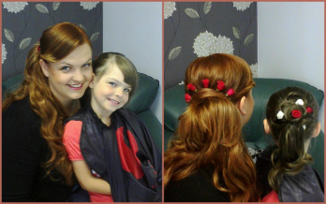[/productImage1] | Image 3 | [productImage2]  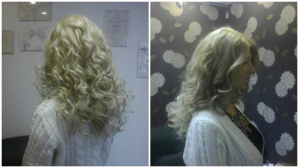[/productImage2]
Image 2 | [productImage3]  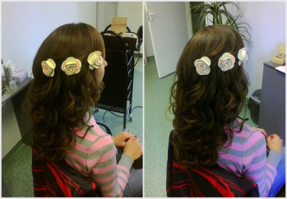  [/productImage3] | Image 4 | [productImage4]  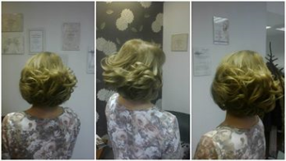  [/productImage4]
Display this? | [delete]Yes[/delete]
[/product1]

Product Page –ITEM 2
PRODUCT PAGE
[product2]
Product Heading  PRODUCT PAGE | [productMainHeading]Male Cuts[/productMainHeading]
Text (use 1 paragraph only) | [productText]…introducing different male cuts shown on different nationalities of men. Choose Your Favourite :) [/productText]
Price | [productPrice]29[/productPrice]
Image 1 | [productImage1]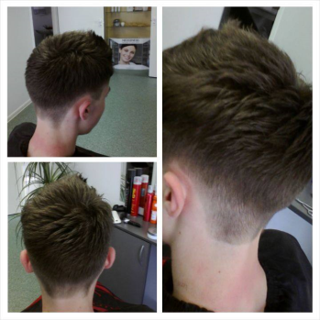[/productImage1] | Image 3 | [productImage2]  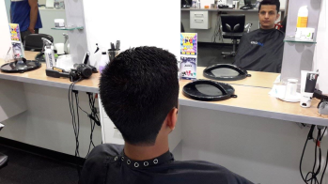[/productImage2]
Image 2 | [productImage3]  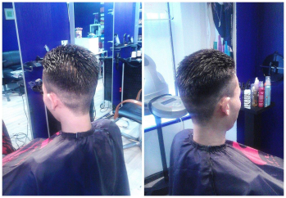  [/productImage3] | Image 4 | [productImage4]  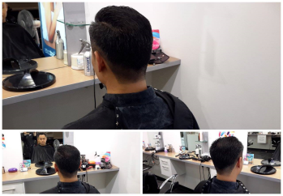  [/productImage4]
Display this? | [delete]Yes[/delete]
[/product2]

Product Page - ITEM 3
[product3]
Product Heading  PRODUCT PAGE | [productMainHeading]Female Cuts[/productMainHeading]
Text (use 1 paragraph only) | [productText]Introducing short and long cuts, from classy to funky. Choose Your Favourite :)[/productText]
Price | [productPrice]29[/productPrice]
Image 1 | [productImage1][/productImage1] | Image 3 | [productImage2]  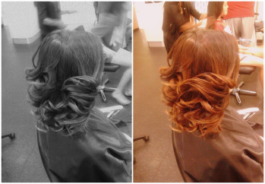[/productImage2]
Image 2 | [productImage3]  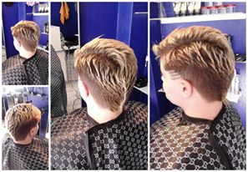  [/productImage3] | Image 4 | [productImage4]  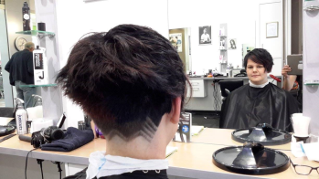  [/productImage4]
Display this? | [delete]Yes[/delete]
[/product3]

PRODUCT PAGE

Product Page–ITEM 4
[product4]
Product Heading  PRODUCT PAGE | [productMainHeading] Childrens Cuts [/productMainHeading]
Text (use 1 paragraph only) | [productText]You are welcome to have a look at children cuts, you might find something suitable for your child.[/productText]
Price | [productPrice]21[/productPrice]
Image 1 | [productImage1]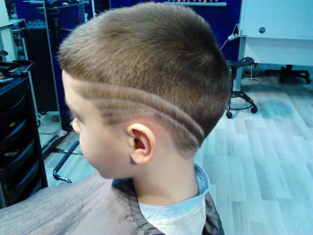[/productImage1] | Image 3 | [productImage2]  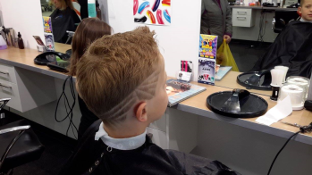[/productImage2]
Image 2 | [productImage3]  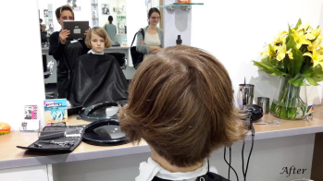  [/productImage3] | Image 4 | [productImage4]  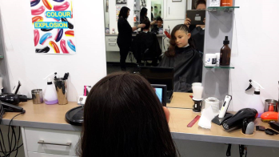  [/productImage4]
Display this? | [delete]Yes[/delete]
[/product4]

Product Page - ITEM 5
PRODUCT PAGE
[product5]
Product Heading  PRODUCT PAGE | [productMainHeading]Patterns[/productMainHeading]
Text (use 1 paragraph only) | [productText]I always more than happy to experiment, if you have an idea for your hair, come along, we’ll manifest it [/productText]
Price | [productPrice]18[/productPrice]
Image 1 | [productImage1]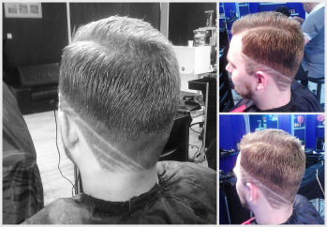[/productImage1] | Image 3 | [productImage2]  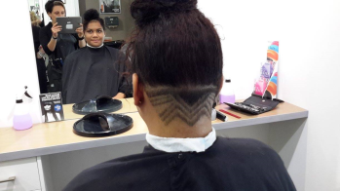[/productImage2]
Image 2 | [productImage3]  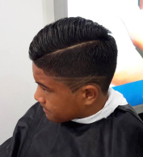  [/productImage3] | Image 4 | [productImage4]  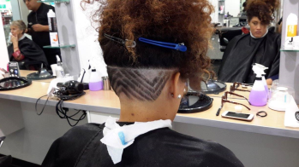  [/productImage4]
Display this? | [delete]Yes[/delete]
[/product5]

Product Page - ITEM 6
PRODUCT PAGE
[product6]
Product Heading  PRODUCT PAGE | [productMainHeading] [/productMainHeading]
Text (use 1 paragraph only) | [productText] [/productText]
Price | [productPrice] [/productPrice]
Image 1 | [productImage1][/productImage1] | Image 3 | [productImage2]  [/productImage2]
Image 2 | [productImage3]  [/productImage3] | Image 4 | [productImage4]  [/productImage4]
Display this? | [delete]No[/delete]
[/product6]

Product Page - ITEM 7
PRODUCT PAGE
[product7]
Product Heading  PRODUCT PAGE  PRODUCT PAGE | [productMainHeading] [/productMainHeading]
Text (use 1 paragraph only) | [productText] [/productText]
Price | [productPrice] [/productPrice]
Image 1 | [productImage1][/productImage1] | Image 3 | [productImage2]  [/productImage2]
Image 2 | [productImage3]  [/productImage3] | Image 4 | [productImage4]  [/productImage4]
Display this? | [delete]No[/delete]
[/product7]
[/product]

CUSTOM Page 1

Please name the page  [for button on website’s banner]  Display The Page? | [customPage]Natural Hair Treatment [delete]  Yes[/delete] [/customPage]
Page Heading & Text

Heading | [customContentHeading]Natural Hair Treatment Products[/customContentHeading]
Centre Text  (use 1 paragraph only) | [customContentParaHeading] [/customContentParaHeading]

CUSTOM PAGE 1 - Link to Videos

Show Video?  (instead of Slideshow) | [customPageIsVideo]No[/customPageIsVideo]

Video 1 Name | [customPageVideoName1] [/customPageVideoName1]
Video URL | [customPageVideo1] [/customPageVideo1]
Video 2 Name | [customPageVideoName2] [/customPageVideoName2]
Video 2 URL | [customPageVideo2] [/customPageVideo2]
Video 3 Name | [customPageVideoName3] [/customPageVideoName3]
Video 3 URL | [customPageVideo3] [/customPageVideo3]

CUSTOM PAGE 1 – VIDEO, Heading & Text
Heading above Video | [customPageHeader] [/customPageHeader]
Text Above Video | [customPageContent1] [/customPageContent1]
Text Below Video | [customPageContent2] [/customPageContent2]

CUSTOM PAGE 1 -Text for the Slider
CUSTOM PAGE 1
[customSlider]

Enter a cross in the brackets here
[customSliderSameHeading] [YES] [/customSliderSameHeading] to assign the same heading & subheading on all slidesOr, enter unique text on each slide
[customSlider1]
Name of Button on Slider | [ButtonName] [/ButtonName]
Button Web Address Link | [anchorTag] [/anchorTag]
Slider Heading | [heading]Penetrate Your Hair! [/heading]
Slider Subheading | [subHeading] [/subHeading]

Images for the Slider
[
Image 1 | [sliderImage]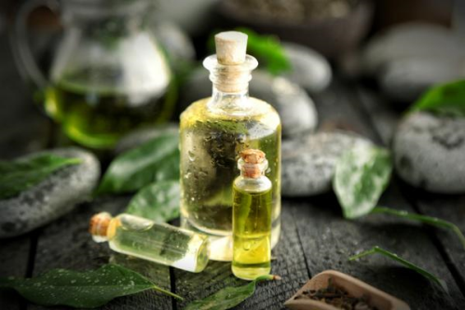[/sliderImage]  [/Customslider1] | Image 4 | [Customslider4]  [sliderImage]  [/sliderImage]  [/Customslider4]
Image 2 | [Customslider2]  [sliderImage]  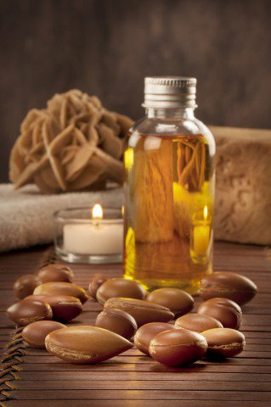[/sliderImage]  [/Customslider2] | Image 5 | [Customslider5]  [sliderImage][/sliderImage]  [/Customslider5]
Image 3  CUSTOM PAGE 1 | [Customslider3]  [sliderImage]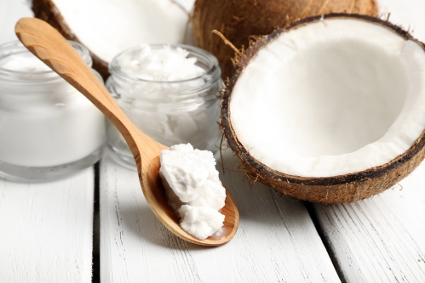[/sliderImage]  [/Customslider3]

CUSTOM PAGE 1 -Photos & Information Area
CUSTOM PAGE 1
Your user can press a button & download files: Name the button & file (e.g. Menu.png)& attach the downloaded file with the word document in the same email, for help Control Click Here
[customPageSection]
[customPageSection1]
Photo | [customImage]  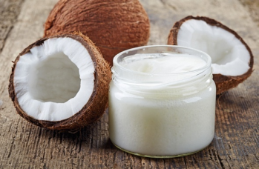[/customImage]
Heading | [customHeading]Coconute Oil[/customHeading]
Subheading | [customSubHeading]TO REMEMBER: Not all coconut oils are the same[/customSubHeading]
Text (use 1 paragraph only) | [customContent]Hair care: Coconut oil helps in healthy growth of hair and gives your hair a shiny quality. It is also highly effective in reducing protein loss, which can lead to various unattractive or unhealthy qualities in your hair. It is used as hair care oil and is used in manufacturing various conditioners and dandruff relief creams. It is normally applied topically for hair care.[/customContent]
Download Button Name | [customButtonName] [/customButtonName]
Name of Downloadable File | [fileName][customPageSection1] [/fileName]  [/customPageSection1]

CUSTOM PAGE 1 - ITEM 2
[customPageSection2]
Photo | [customImage]  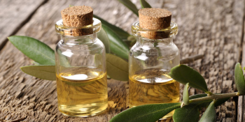  [/customImage]
Heading | [customHeading]Tea Tree Oil[/customHeading]
Subheading | [customSubHeading]There are many ways to use tea tree oil[/customSubHeading]
Text (use 1 paragraph only) | [customContent]Tea Tree oil has proven very beneficial for the health of your hair and scalp. Like coconut oil for hair, tea tree oil has the ability to soothe dry flaking skin, remove dandruff and even can be used for the treatment of lice. To make homemade tea tree oil shampoo, mix several drops of tea tree essential oil with aloe vera gel, coconut milk and other essential oils like lavender oil.[/customContent]
Download Button Name | [customButtonName] [/customButtonName]
Name of Downloadable File | [fileName] [/fileName]
[/customPageSection2]

CUSTOM PAGE 1

CUSTOM PAGE 1 -ITEM 3
CUSTOM PAGE 1
[customPageSection3]
Photo | [customImage]  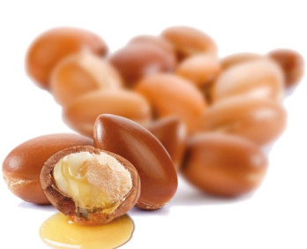  [/customImage]
Heading | [customHeading]Argan Oil[/customHeading]
Subheading | [customSubHeading]The king of all oils for hair[/customSubHeading]
Text (use 1 paragraph only) | [customContent]Argan Oil is three times more concentrated than olive oil to create maximum shine – without any oily feel. Weighteless hair styling product to use daily. Contains high levels of Vitamin E. Seals and reoairs the cuticle locking in hair colour and adding shine.[/customContent]
Download Button Name | [customButtonName] [/customButtonName]
Name of Downloadable File | [fileName] [/fileName]
[/customPageSection3]

CUSTOM PAGE 1 - ITEM 4
[customPageSection4]
Photo | [customImage]  [/customImage]
Heading | [customHeading] [/customHeading]
Subheading | [customSubHeading] [/customSubHeading]
Text (use 1 paragraph only) | [customContent] [/customContent]
Download Button Name | [customButtonName] [/customButtonName]
Name of Downloadable File | [fileName] [/fileName]
[/customPageSection4]
[/customPageSection]

CUSTOM Page 2
CUSTOM PAGE 2

Please name the page  [for button on website’s banner]  Display The Page? | [customPageTwo] Professional Advice [delete]  No[/delete] [/customPageTwo]
Page Heading & Text

Heading | [customContentHeadingTwo] [/customContentHeadingTwo]
Centre Text  (use 1 paragraph only) | [customContentParaHeadingTwo] [/customContentParaHeadingTwo]

CUSTOM PAGE 2 - Link to Videos
Show Video?  (instead of Slideshow) | [customPageIsVideoTwo]Yes[/customPageIsVideoTwo]

Video 1 Name | [customPageTwoVideoName1] Strong bonds by Schwarzkopf Professional[/customPageTwoVideoName1]
Video URL | [customPageTwoVideo1]https://www.youtube.com/watch?v=V1tCIsbP73A[/customPageTwoVideo1]
Video 2 Name | [customPageTwoVideoName2] Schwarzkopf FibrePlex [/customPageTwoVideoName2]
Video 2 URL | [customPageTwoVideo2] https://www.youtube.com/watch?v=p0fj4U4FXQs [/customPageTwoVideo2]
Video 3 Name | [customPageTwoVideoName3] BlondMe Decoloration & Tone Schwarzkopf Professional [/customPageTwoVideoName3]
Video 3 URL | [customPageTwoVideo3] https://www.youtube.com/watch?v=o82NtTrR7ws [/customPageTwoVideo3]

CUSTOM PAGE 2 - VIDEO Heading & Text
Heading above Video | [customPageTwoHeader] Professional Advice [/customPageTwoHeader]
Text Above Video | [customPageTwoContent1] [/customPageTwoContent1]
Text Below Video | [customPageTwoContent2] [/customPageTwoContent2]

CUSTOM PAGE 2 - Text for the Slider
[customSliderTwo]
Enter a cross in the brackets here [customSliderTwoSameHeading] [YES] [/customSliderTwoSameHeading] to assign the same heading & subheading on all slidesOr, enter unique text on each slide
[customSliderTwo1]
Name of Button on Slider | [ButtonName] [/ButtonName]
Button Web Address Link | [anchorTag] [/anchorTag]
Slider Heading | [heading] [/heading]
Slider Subheading | [subHeading] [/subHeading]

CUSTOM PAGE 2 - Images for the Slider
Image 1 | [sliderImage][/sliderImage]  [/CustomsliderTwo1] | Image 4 | [CustomsliderTwo4]  [sliderImage]  [/sliderImage]  [/CustomsliderTwo4]
Image 2 | [CustomsliderTwo2]  [sliderImage]  [/sliderImage]  [/CustomsliderTwo2] | Image 5 | [CustomsliderTwo5]  [sliderImage][/sliderImage]  [/CustomsliderTwo5]
Image 3 | [CustomsliderTwo3]  [sliderImage][/sliderImage]  [/CustomsliderTwo3]

[/customSliderTwo]

CUSTOM PAGE 2
CUSTOM PAGE 2

CUSTOM PAGE 2 - Photos & Information Area
[customPageTwoSection]
[customPageTwoSection1]
Photo | [customImage]  [/customImage]
Heading | [customHeading] [/customHeading]
Subheading | [customSubHeading] [/customSubHeading]
Text (use 1 paragraph only) | [customContent] [/customContent]
Download Button Name | [customButtonName] [/customButtonName]
Name of Downloadable File | [fileName] [/fileName]
[/customPageTwoSection1]

CUSTOM PAGE 2 - ITEM 2
[customPageTwoSection2]
Photo | [customImage]  [/customImage]
Heading | [customHeading] [/customHeading]
Subheading | [customSubHeading] [/customSubHeading]
Text (use 1 paragraph only) | [customContent] [/customContent]
Download Button Name | [customButtonName]] [/customButtonName]
Name of Downloadable File | [fileName] [/fileName]
[/customPageTwoSection2]

CUSTOM PAGE 2

CUSTOM PAGE 2 -ITEM 3
CUSTOM PAGE 2
[customPageTwoSection3]
Photo | [customImage]  [/customImage]
Heading | [customHeading] [/customHeading]
Subheading | [customSubHeading] [/customSubHeading]
Text (use 1 paragraph only) | [customContent] [/customContent]
Download Button Name | [customButtonName] [/customButtonName]
Name of Downloadable File | [fileName] [/fileName]
[/customPageTwoSection3]

CUSTOM PAGE 2 - ITEM 4
[customPageTwoSection4]
Photo | [customImage]  [/customImage]
Heading | [customHeading] [/customHeading]
Subheading | [customSubHeading] [/customSubHeading]
Text (use 1 paragraph only) | [customContent] [/customContent]
Download Button Name | [customButtonName] [/customButtonName]
Name of Downloadable File | [fileName] [/fileName]
[/customPageTwoSection4]
[/customPageTwoSection]

APPENDIX

Feature Icons
User clicks icon to go to page indicated
[FeatureContent]
 | Heading | [content1]  [contentHeading]Know more about my work![/contentHeading]
 | Text | [contentSubHeading] Email me or phone[/contentSubHeading]
 | Show This | [delete]Yes[/delete]  [/content1]
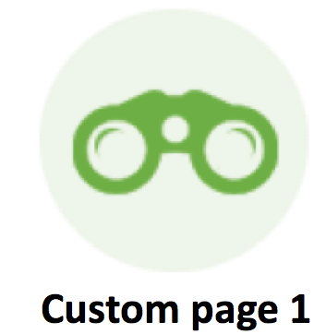 | Heading | [content2]  [contentHeading]For more haircuts click here[/contentHeading]
 | Text | [contentSubHeading]Male/Female/Children[/contentSubHeading]
 | Show This | [delete]Yes[/delete]  [/content2]
 | Heading | [content3]  [contentHeading] We’d love to hear from you [/contentHeading]
 | Text | [contentSubHeading]We’re waiting for you here at the Salon[/contentSubHeading]
 | Show This | [delete]Yes[/delete]  [/content3]
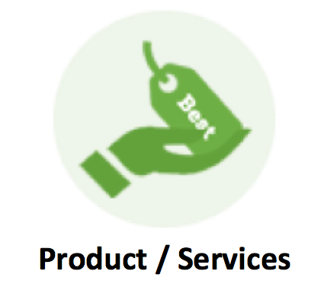 | Heading | [content4]  [contentHeading] How can we help?[/contentHeading]
 | Text | [contentSubHeading]Take a look at our Services[/contentSubHeading]
 | Show This | [delete]Yes[/delete]  [/content4] [/content]
[/FeatureContent]

Testimonials
APPENDIX
[Testimonials]
Testimonial 1 Description | [testimonials1] [TestimonialDescription]Amazing! Their attention to detail was increadible[/TestimonialDescription]
Person | [TestimonialPerson]Mark[/TestimonialPerson]
Title | [TestimonialPersonTitle]Mechanic[/TestimonialPersonTitle]
Show This? | [delete]Yes[/delete] [/testimonials1]
Testimonial 2 Description | [testimonials2] [TestimonialDescription]Very creative and welcoming. I was really in need of a good haircut and I definitely have got one. Not only that I am going to come back again but I’ll recommend you for family and friends[/TestimonialDescription]
Person | [TestimonialPerson]Danny[/TestimonialPerson]
Title | [TestimonialPersonTitle]Army Officer[/TestimonialPersonTitle]
Show This? | [delete]Yes[/delete] [/testimonials2]
Testimonial 3 Description | [testimonials3] [TestimonialDescription]Thanks for making my day! You gave me one of the best haircuts I’ve ever had.[/TestimonialDescription]
Person | [TestimonialPerson]Laura[/TestimonialPerson]
Title | [TestimonialPersonTitle]Manager[/TestimonialPersonTitle]
Show This? | [delete]Yes[/delete]  [/testimonials3] [/Testimonials]
[/Testimonials]

More Options
Product Page Currency (e.g. $, €,£) | [currencyType] $ [/currencyType]
Background Tiling  (image’s best under 500kb)  (Choose light & non-aggressively colored backgrounds. For great examples Control Click  Here ) | [backgroundImage][/backgroundImage]
Unique Banner Image  (Use a wide image!) | [bannerImageBackground][/bannerImageBackground]
APPENDIX

